**1.What is Linux? Why Linux? Give 3 examples of Linux distributions?**  Daliah Aljutayli

**Linux** is an operating system “OS” Like Windows and Mac, which is a software which manages all the communication between the hardware resources and the software in the PC/Laptop [1].

**Why Linux** because [1]:

* Reliability with zero cost: install Linux on many computers without paying a cent for software or server licensing.
* Open source license: distributed under an open source license with these philosophies of the freedom to:
* Run the program.
* Study how the program works.
* Change the program as you wish.
* Redistribute copies so you can help anyone.
* Stable OS: no blue screen of death does happen nor registry errors [2].
* Secure: fewer victim of viruses or other malware [2].

**Examples of Linux distributions** [1]**:**

1. [Ubuntu Linux](http://www.ubuntu.com/).
2. [Linux Mint](http://www.linuxmint.com/).
3. [Fedora](http://fedoraproject.org/).

**2.What is the filesystem in Linux? Understand layout in a Linux VPS (Virtual Private Server).**

**Filesystem** is contained within a single tree, regardless of how many devices are incorporated.

* All components accessible to the operating system are represented somewhere in the main filesystem.
* 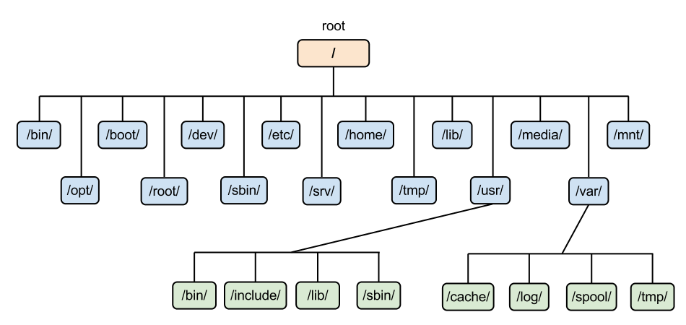Every file and device on the system resides under the **root** directory **/**.
* To move throughout the filesystem, we use commands such as **cd**, which stands for **change directory**.
* If you have a filesystem on a remote system that you would like to mount on your server use the VPS environment for mounting network accessible drives [3].

**3.What is (Shell, Bash)?**

**Shell**: a program that takes commands from the keyboard and gives them to the operating system to perform [4] (Takes terminal’s Command and deal with them).

**Bash**: a text-based command line user interface that user interacts the PC through a GUI [5] (commands run inside terminal Windows).

---------------------------------------------------------------------------------------------------------------------

[1]"What is Linux?", Linux.com | The source for Linux information, 2019. [Online]. Available: https://www.linux.com/what-is-linux. [Accessed: 23- Jun- 2019].

[2]"What Is Linux? | The Linux Gamer", YouTube, 2019. [Online]. Available: https://www.youtube.com/watch?v=tFFNiMV27VY. [Accessed: 23- Jun- 2019].

[3]"How To Understand the Filesystem Layout in a Linux VPS | DigitalOcean", *Digitalocean.com*, 2019. [Online]. Available: https://www.digitalocean.com/community/tutorials/how-to-understand-the-filesystem-layout-in-a-linux-vps#an-overview-of-the-linux-filesystem-layout. [Accessed: 23- Jun- 2019].

[4]J. William Shotts, "LinuxCommand.org: Learning the shell.", *Linuxcommand.org*, 2019. [Online]. Available: http://www.linuxcommand.org/lc3_learning_the_shell.php. [Accessed: 23- Jun- 2019].

[5]"What is the Shell?", *YouTube*, 2019. [Online]. Available: https://www.youtube.com/watch?v=AAnn0PNmZew. [Accessed: 23- Jun- 2019].